Multiple-choice section

Question 1 [3.1]

If Taha ate  of the 12 lollies in this bag, how many did he eat?

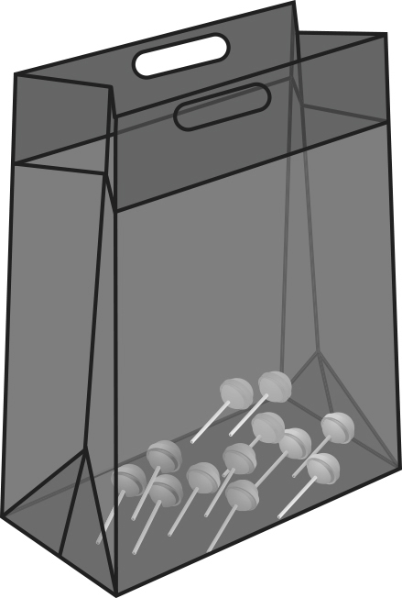  
A 3 B 4 C 8 D 12

Question 2 [3.1]

Which of the following improper fractions is equal to the whole number 3?

A  B  C  D 

Question 3 [3.1]

Which of the following is closest to 1 whole?

A  B  C  D 

Question 4 [3.2]

Which of the following fractions is the simplest form of ?

A **** B  C **** D 

Question 5 [3.4]

**** =

A **** B **** C **** D ****

Question 6 [3.3]

The fraction  is:

A less than 1 B greater than 1, but less than 2

C greater than 2, but less than 3 D greater than 4

Question 7 [3.5]

of $35 =

A $5 B $7 C $10 D $14

Question 8 [3.6]

**** ÷ **** =

A 3 B 4 C 6 D 8

Multiple-choice total marks: \_\_\_\_ / 8

Short answer section

Question 9 2 marks [3.1]

Use words from the list below to complete the following sentences.

improper fraction numerator  mixed number  unit fraction proper fraction denominator

(a) The \_\_\_\_\_\_\_\_\_\_\_\_\_\_\_ is the top number in a fraction, below the fraction bar.

(b) A \_\_\_\_\_\_\_\_\_\_\_\_\_\_\_\_\_ has a value less than one.

Question 10 1 mark [3.1]

Write a fraction or mixed number to show the amount that each person receives if 3 pizzas are shared equally between 4 people.

Question 11 2 marks [3.2]

Find equivalent fractions by completing the following.

(a) (b)

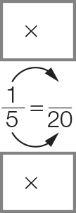 **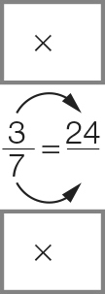**

Question 12 8 marks [3.3]

For each pair of fractions:

(i) find the LCD (lowest common denominator)

(ii) write each fraction as an equivalent fraction with the LCD

(iii) insert a > (greater than), < (less than) or = (equal to) symbol between them

(iv) insert a > (greater than), < (less than) or = (equal to) symbol between the original fractions.

|  |  |
| --- | --- |
| (a) , | (b) , |
| (i) LCD = \_\_\_\_ | (i) LCD = \_\_\_\_ |
| (ii) = | (ii) = |
| = | = |
| (iii) \_\_\_\_ | (iii) \_\_\_\_ |
| (iv) So \_\_\_\_ | (iv) So \_\_\_\_ |

Question 13 9 marks [3.4]

Complete the following. Write your answers in simplest form and as mixed numbers, if possible.

|  |  |  |
| --- | --- | --- |
| (a)  + | (b) – | (c) |
| =  + | =  − | = + | |
| = | = | = | |
|  | = (simplify) | = 1 (mixed number) | |

Question 14 6 marks [3.5]

Calculate the following. Write your answers in simplest form.

|  |  |  |
| --- | --- | --- |
| (a) of $30 | (b) of | (c) |
|  |  | = |
| = | = | = |
| = \_\_\_\_\_\_ |  |  |

Question 15 6 marks [3.6]

Complete the following. Write your answers in simplest form and as mixed numbers, if possible.

|  |  |  |
| --- | --- | --- |
| (a) 3 ÷ | (b) ÷ | (c) ÷ 5 |
| = × | = × | = × |
| = | = | = |
| = \_\_\_\_\_\_ | = 1 (mixed number) |  |

Short answer total: \_\_\_\_\_\_\_ /34

Extended answer section

Question 16 5 marks [3.1, 3.4, 3.5]

A shopping basket contains six carrots, four cucumbers, four bananas and two pineapples.

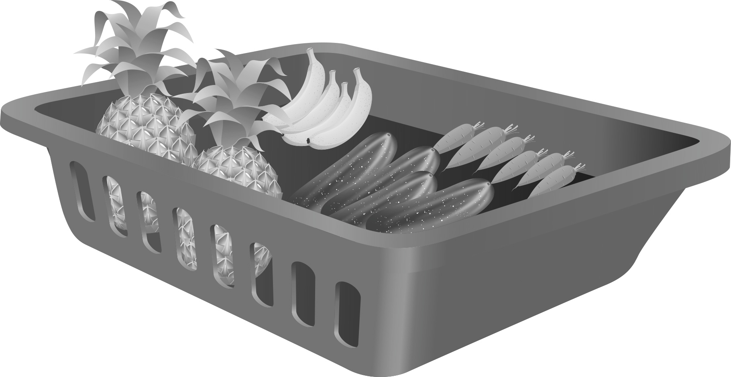

Give your answers to the following in simplest form.

(a) What fraction of the total number of fruit and vegetables are:

(i) carrots

(ii) pineapples

(b) What fraction of the total does all of the fruit (bananas and pineapples) represent?

(c) If of all of the items in the basket were removed, how many would be left?

Question 17 9 marks [3.1, 3.2, 3.3]

(a) Use arrows to indicate the position of the following fraction or mixed numbers on the number line below:

,,, 

Macintosh HD:Users:lizwaud:Desktop:PM7_eBook:Batch 1 commenced:Artwork_CORRECTED_041016_Use this:Ch3:PM2e_07_EB_03_FBT_05.jpg

(b) Write the mixed numbers in the list in (a) as improper fractions.

(c) Use the number line above to help you write the whole number 2 as an improper fraction with a denominator of:

(i) 5 (ii) 10

(d) Which of the fractions you have placed on the number line would be closest to ?

(e) Place this list of fractions in ascending order (from smallest to largest). You could use the number line above to help you compare the sizes of fractions in the list.

, ,, 

Extended answer total: \_\_\_\_\_\_\_ / 14

TOTAL test marks: \_\_\_\_\_\_\_ / 56